
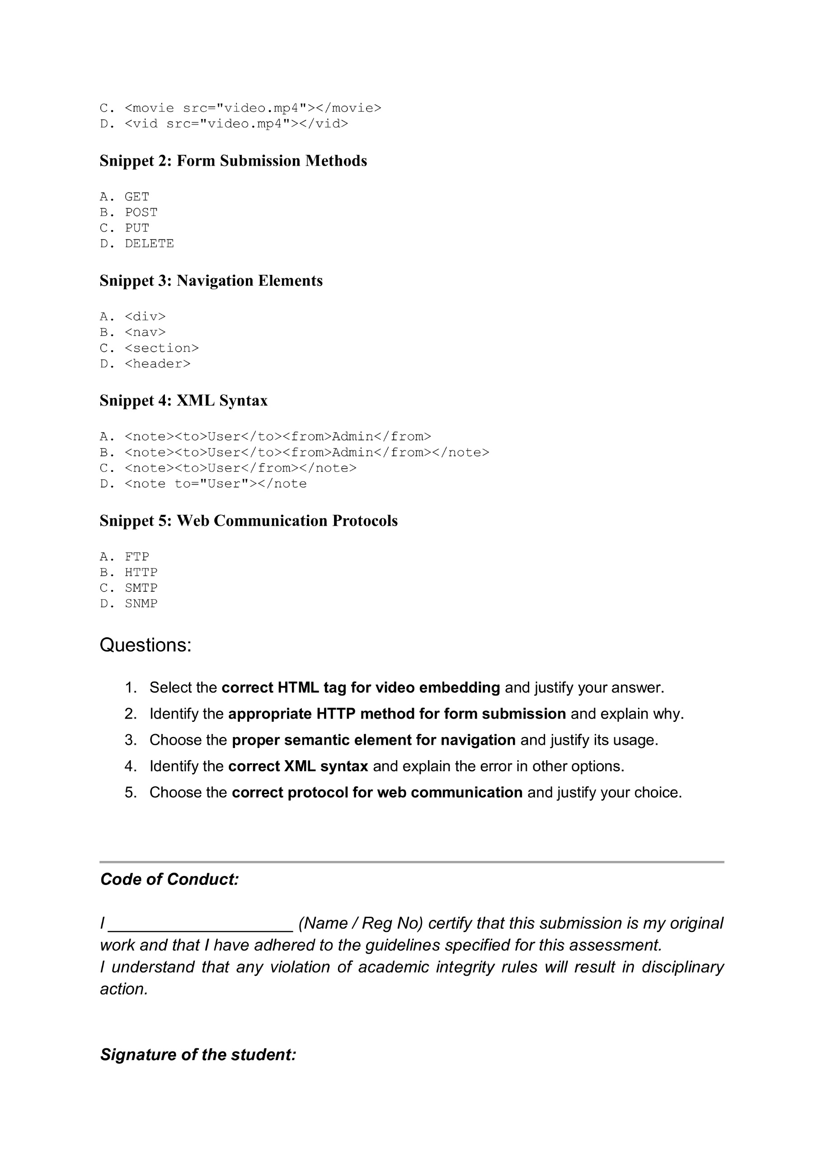

Code of Conduct:

I Dhanush Kumar R (192411215) certify that this submission is my original work and that I have adhered to the guidelines specified for this assessment.
I understand that any violation of academic integrity rules will result in disciplinary action.


Signature of the student:
Question 1: Select the correct HTML tag for video embedding and justify your answer.
Correct Answer: B. <video src="video.mp4" controls></video>
Justification:
The <video> tag is the standard HTML5 element used to embed videos in a webpage. The controls attribute allows users to play, pause, and adjust the volume. The other options (<media>, <movie>, and <vid>) are not valid HTML tags.

Question 2: Identify the appropriate HTTP method for form submission and explain why.
Correct Answer: B. POST
Explanation:
The POST method is used to send form data securely to the server. It sends data in the request body instead of the URL, making it suitable for sensitive information such as passwords and personal details.

Question 3: Choose the proper semantic element for navigation and justify its usage.
Correct Answer: B. <nav>
Justification:
The <nav> element defines a section containing navigation links. It improves the webpage structure, accessibility, and search engine optimization (SEO). It clearly identifies the navigation menu for browsers and screen readers.

Question 4: Identify the correct XML syntax and explain the error in other options.
Correct Answer: B.
<note><to>User</to><from>Admin</from></note>
Explanation:
XML requires all tags to be properly opened and closed. Option B follows the correct XML syntax. The other options contain missing or mismatched closing tags, making them invalid XML documents.

Question 5: Choose the correct protocol for web communication and justify your choice.
Correct Answer: B. HTTP
Justification:
HTTP (HyperText Transfer Protocol) is the standard protocol used for communication between web browsers and web servers. It enables users to request and receive web pages. FTP is used for file transfer, SMTP for email, and SNMP for network management.



